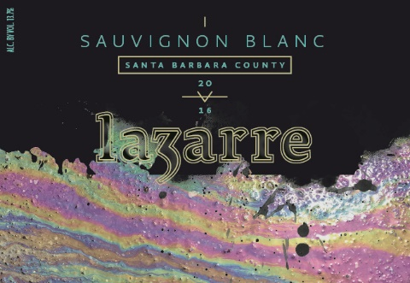
Current Awards
2018 - Summer

2012 LaZarre Pinot Noir ~ Central Coast
Platinum - 95 points ~ Best Pinot Noir ~ 2015 Monterey International Wine Competition
95 points ~ Wine Review Online, Rich Cook
Gold - 93 points ~ 2014 Sommelier Challenge International Wine & Spirits Competition
Bronze ~ 2015 Sunset International Wine Comp
BEST OF CLASS – Double Gold - San Francisco Int’l Wine Competition 2017
2016 LaZarre Sauvignon Blanc ~ Santa Barbara County
93 points – IntoWine, Michael Cervin, www.intowine.com
94 points – Wine Review Online, Rich Cook
2016 LaZarre Albarino ~ Edna Valley
92 Points – Wine Review Online, Rich Cook
92 Points – IntoWine, Michael Cervin, www.intowine.com
2014 LaZarre Merlot – Paso Robles
Gold - 91 points Los Angeles International Wine Competition
2014 LaZarre Pinot Noir – Sta. Rita Hills
Gold - 90 points Critics Challenge 2018
93 points - Bonforts Magazine
2014 LaZarre MOSHINA – Paso Robles
Gold - 90 points San Diego International Wine Competition
Silver - Los Angeles International Wine Competition
Bronze – Central Coast Wine Competition

Stay tuned for more to come! We love Heavy Metals !!!
Cheers and Love always, Adam and Angie LaZarre Updated 04.08/18
